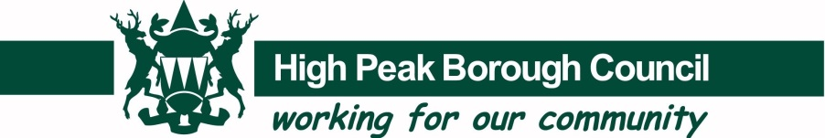
Nomination Form for Sports and Physical Activity Achievement Awards in 2019

Name of Nominee
Section A

Address of Nominee

Postcode

Telephone No.  (Daytime) |  | Telephone No. (Evening)

Email address
Award Nominated for – (Please Tick or type YES in box)

Senior Sports Team |  | Sportsman of the Year
Sportswoman of the Year |  | Innovation of the Year
Junior sportsman of the Year U’18 |  | Junior Sports woman of the Year u’18
Coach of the Year |  | Service to sport
Volunteer of the Year |  | Junior Sports Team
Club of the Year

Junior under 18 yrs. Please give DOB

Sport of Nominee
Club of Nominee

Name, Address and telephone number of person nominating.
Signed |  | Date

Please return forms to: cathy.hinde@highpeak.gov or jayne.woolliscroft@staffsmoorlands.gov.uk
High Peak Borough Council, Fowlchurch Depot, Fowlchurch Road, Leek Staffordshire ST13 6BH
Section B

1. | For the Senior award, please include level of competition (e.g. Local, County, Regional, National etc).
2. | For the Team award please state if you are part of a club that is developing and working  towards attaining Clubmark accreditation and include level of competition (e.g. Local,  County, Regional, National etc.
3. | For the Coach award please state if they have been proactive in developing the sport within the local community and have shown an overwhelming commitment to the sport that they coach in 2019 e.g. support local groups and schools with coaching opportunities, encourage the development of new athletes and teams. Please include level of competition (e.g. Local, County, Regional, National etc).
 | So that the nomination can be considered in detail, please list nominee’s achievements in 2019 plus any other relevant information.

