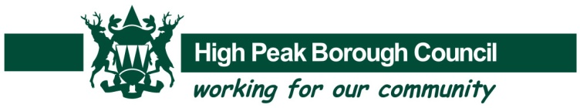

Coronation Grant Fund
Application Form

The Council is providing grants to parish/town councils and to community groups in areas where there is no town/parish council in the High Peak to support their involvement in holding an event or activity.

Parish/town councils may wish to make a joint application or the fund could be available to community groups where the town/parish council gives its support to the application.

A grant of £750 is available for each of the three larger parish/town councils (Whaley Bridge, New Mills and Chapel-en-le-Frith) with £550 available for each of the remaining parish councils in the High Peak. The balance of the grant fund is available to community groups organising events and activities in areas not represented by a parish/town council, up to a maximum grant of £750 for each event on a first come first served basis.

Applications for grants should be made by 22 March 2023.

Information and resources on getting involved is available at https://coronation.gov.uk/get-involved/

Name of parish/town council or community group

Contact Name:
(in the case of parish/town councils this must be the parish/town clerk)
Full Postal Address:

Postcode:
E-mail:
Telephone:

Activity or Event Details
The grant must be used to hold an activity or event directly related to the Coronation or for preparations leading up to an event on the Coronation Bank Holiday weekend 6-8 May 2023. Please confirm this is the case.

Please provide details of your activity or event.

Approximately how many people do you aim to attract or involve?
Please confirm that you will register your activity/event on the Coronation website

Event organisation
Is the event being organised directly by a parish/town council or by another organisation on its behalf supported by the parish/town council?

If by another organisation please provide the contact details of that organisation.

Please confirm that relevant health and safety requirements will be complied with (e.g. completion of a risk assessment and an event plan).

We want to encourage as many and as wide a range of local people as possible to be involved in events and activities. The Coronation provides an opportunity to bring together people from across our communities and the Council wishes to encourage everyone to think about how their planned activities and events can achieve this.
Please confirm that your activity/event is open to the general public and that you have actively considered how to encourage the widest possible involvement.

Financial Details
What element of the event will the grant be contributing to?

Total cost of the project is estimated to be: |  | £
I hereby apply for a grant of (the maximum grant available is):  - Chapel-on-le-Frith, New Mills, Whaley Bridge - £750 each  - All other parishes - £550 each  - A maximum of £750 for events organised by community groups in areas where there is not a parish/town council |  | £
Please provide parish/town/community group bank account details:
(Payment cannot be made to individuals and will be made by BACS transfer)

Account Name:

Sort Code:

Account No:

Declaration:

Please note that you will be expected to keep an account of expenditure on the project through receipts and journals and provide these on request to evidence that the grant has been spent on what has been applied for. Please also note that the grant award must only be spent on the project as outlined in this application form.

I declare the information provided within this application is correct to the best of my knowledge and will provide monitoring information throughout and at the end of the
project if requested.

Name:…………………………………………………………………………………………..
Position:………………………………………………………………………………………..
(this must be the clerk if completed on behalf of a parish/town council)
Name of parish/town council or community group

………………………………………………………….……………………………………….

Signature:………………………………………………………………………………………

Please email your completed form to democratic.services@highpeak.gov.uk.

